ITECH1400 - Assignment 1 – Container Recycling Machine

Student Name: Student ID:

Assignment Part 1 Details – Class Design
Insert your list/table of possible Container properties here…

Container Properties (All)
name | price | colour | shape
Weight | Height | Width or radius | Area of circumference
Volume | material

Insert your list/table of key product properties here…

Container Properties (Key)
name | price

Complete the class diagram of your final Container class here…

Container Class Diagram
Container
+name: string
+price : flaot
+ Container()

Container_Recycling_Machine Class Diagram
Complete the class diagram of your final Recycling class here…
Container_Recycling_Machine

+paper: int
+bottle: int
+box: int
+can: int
+balance: float
+money: float
+n_item: int
+item: sting

+Container_Recycling_Machine()
+accept_product()
+select_product()
+payout()

Assignment Part 2 – Activity Flowchart
Insert your activity flowchart of the recycling machine process here… If your flowchart is large then place it on the following page.
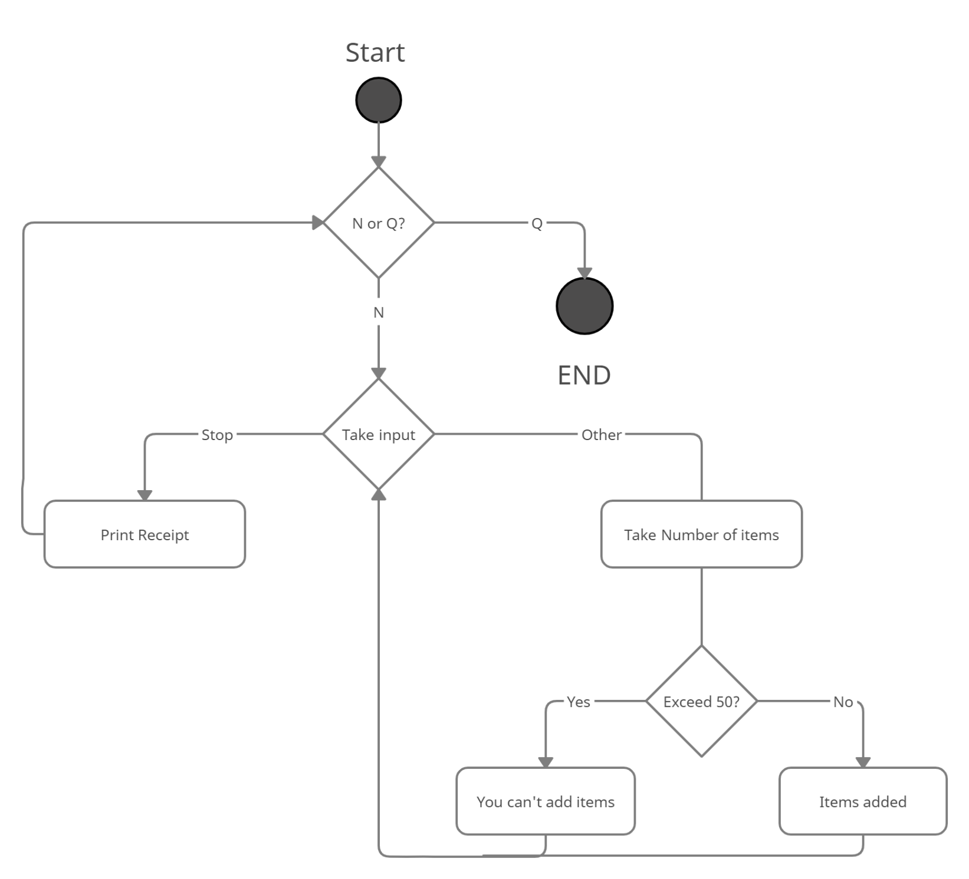

Assignment Part 3 – Software Implementation
Do not place your code here – provide the code as separate .py files submitted with this document.

Assignment Part 4 – Code Explanation and Use
Update the below code to insert comments describing what the code is doing – for each line starting with a hash symbol (#) you should write your code comments after the hash. You may add a second line of comments if you require more space.

# Function to: get integer from user as input
def get_int(prompt):

# initialize variable as integer value 0
value = int(0)

# make a loop until the condition get False
while True:
try:
# get input from user and convert it to integer
value = int(input(prompt))

# if value is less then 0 then show the message
if value < 0:
print("We don't accept a negative number of items!")
continue

# if value is 0 or greater then 0 then break the loop
break

# if user enter value other then integer then it generates exception
except ValueError:
print('Please enter a valid integer value.')

# It returns the value
return value

# Function to: accept items
def accept_item(item_list):
# creates empty lists of item_list and non_accepted_items
item_list = []
non_accepted_items = []
MAX_WEIGHT = 15.0

# iterate over item_list
for item in item_list:

# check if weight is less then MAX_BAG_WEIGHT
if item.weight > MAX_BAG_WEIGHT:
item_list.remove(item)
non_accepted_items.append(item)

# create list of current_contents
current_contents = []
current_weight = 0.0

# iterate over item_list until it got empty
while len(item_list) > 0:

# store item_list first value in temp_item and remove it from item_list
temp_item = item _list[0]
item_list.remove(temp_item)

# check current_weight and temp_item’s weight is less then MAX_WEIGHT
if current_weight + temp_item.weight < MAX_WEIGHT:

# append temp_item into current_ccontent list
current_contents.append(temp_item)
current_weight += temp_item.weight

# check item_list size is 0 or not
if (len(item_list) == 0):
products_item.append(current_contents)

# if current_weight and temp_item’s weight is greter then MAX_WEIGHT then
Add current_content into item_list

else:
item_list.append(current_contents)

# make current_contents list empty and current_weight to 0.0
current_contents = []
current_weight = 0.0

# iterate over machine_list
for index, bag in enumerate(machine_list):
output = 'Machine ' + str(index + 1) + ' contains: '

# iterate over items
for item in items:
output += item.name + '\t'
print(output, '\n')

# check non_accepted_items is greter then 0
if (len(non_accepted_items) > 0):
output = 'Non-bagged items: '

# iterate over non_accepted_items
for item in non_accepted_items:
output += item + '\t'
print(output,'\n')

Assignment 1 – FedUni Checkout
Student name: Student ID:
Part | Assessment Criteria | Weight | Mark
1a | Identification of properties of a typical item that can be recycled – Container. | 10 * 0.5 = 5 marks
1b | Application of abstraction to identify key properties of a typical Container as well as creation of a suitable Class Diagram. | 4 marks
1c | Identification of the key properties of a Container_Recycling_Machine as well as creation of a suitable Class Diagram which uses those properties, plus the four method signatures provided. | 4 marks
2 | Creation of an activity flowchart which clearly indicates how the program should operate, using the correct symbols for elements such as start/end points, processes and decisions/branches | 10 marks
3 | Programming of the Container Recycling Machine simulation so that it:  - Creates a small number of Container instances that may be accepted,  - Accepts simulated ‘deposting’ of a Container after being identified from a list by the user,  - Adds a Container to the Container_Recycling_Machine list of containers being purchased,  - Allows the deposit of multiple containers,  - Provides ‘virtual money’ to pay for those containers and  - Prints a final receipt with  the number of each container type and the amount for these containers, along with the total number of containers and the total amount paid out.  (See example in the assessments instructions.) | 4 + 4 + 4 + 4 + 4 + 4 = 24 marks. | i)  ii)  iiI)  iv)  v)  vi)  Total:
4a | Analysis and documentation via code comments of the two functions provided. | (8 * 0.5) + (16 * 0.5) = 12 marks
4b | Incorporation of the two functions provided into your main submission so that the program does not crash when an illegal money value is provided, and also virtually ‘bags up’ the products purchased. | 2
Overall | Overall code standard including comments, formatting, variable names | 9
 | Assignment total (out of 70 marks)
 | Contribution to grade (out of 20 marks)
Comments:

